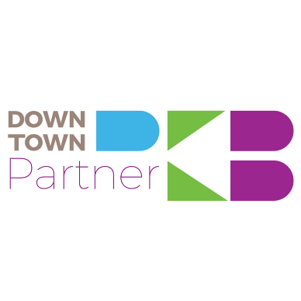
Friends of Downtown PKB
$100 or more
Available to individuals only
- Advance online purchase of tickets and/or reserved seating for select Downtown PKB events
- Recognition on website
Supporter
$250-$499
- Advance online purchase of tickets and/or reserved seating for select Downtown PKB events Recognition on website
- Promotion on Downtown PKB social media sites (over 6,500 total followers)
- Vinyl cling for display at the business/organization
Advocate
$500-$999
- Advance online purchase of tickets and/or reserved seating for select Downtown PKB events
- Recognition on website with business or organization logo
- Promotion on Downtown PKB social media sites, as well as paid social media advertising, up to $50 value (over 6,500 total followers)
- Consulting services
- Vinyl cling for display at the business/organization
- One feature spot on Downtown PKB blog
Champion
$1,000 – $2,499**
- Advance online purchase of tickets and/or reserved seating for select Downtown PKB events Recognition on website with business or organization logo & link
- Promotion on Downtown PKB social media sites, as well as paid social media advertising, up to $100 value (over 6,500 total followers)
- Consulting services
- Vinyl cling for display at the business/organization
- One feature spot on Downtown PKB blog
- One feature spot in the News & Sentinel Downtown PKB column
- Inclusion in a Downtown PKB promotional video
- Recognition at all Downtown PKB events

Visionary
$2,500**
- Advance online purchase of tickets and/or reserved seating for select Downtown PKB events Recognition on website with business or organization description, logo & link
- Promotion on Downtown PKB social media sites, as well as paid social media advertising, up to $250 value (over 6,500 total followers)
- Consulting services
- Vinyl cling for display at the business/organization
- Two feature spots on Downtown PKB blog
- One feature spot in the News & Sentinel Downtown PKB column
- Inclusion in a Downtown PKB promotional video
- Recognition at all Downtown PKB events
- Reserved seating for eight (8) at annual Taste of Parkersburg event ($160 value)

Custom partner levels are available. Please contact Wendy Shriver at 304-865-0522 to find an option that is best for your business or organization.

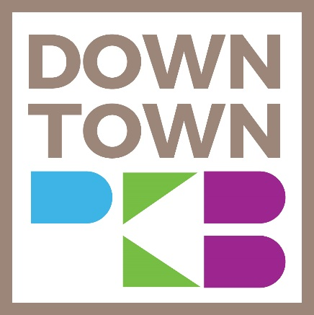

When you invest in Downtown PKB, you are investing in your entire community.

Notes:
Not-for-profit rate is one-half the listed amount. Must provide proof of non-profit status. Maximum of 10 tickets/reserved seating for early purchase, applicable to Taste of Parkersburg, Point Park Concert Series and Downtown Throwdown. Benefits available based on gift commitment date and must be renewed annually. Online payment will be accepted but will include a convenience fee of 2.5%. Downtown PKB is a registered, 501(C)(3) organization and all donations are tax-deductible.
** In-kind services may be used for no more than 50% of the total cost and cannot be restricted to a particular activity or program

